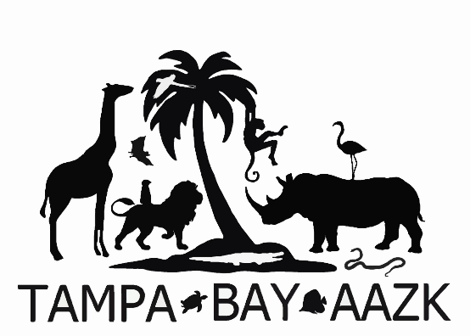
May 25, 2018
5:30pm
at
Pin Chasers Midtown
4847 North Armenia Ave., Tampa, FL, 33603

www.tampabayaazk.com

bowl – buy a t-shirt – raffle – silent auction
prizes include tickets to Busch Gardens, local zoos and attractions, a dolphin swim at Discovery Cove
and MORE!!!

PRE-REGISTRATION @ www.tampabayaazk.com
$30 for 2 hours of bowling, shoe rental, shirt
$20 for 2 hours of bowling, shoe rental OR shirt only
AT THE DOOR PRICING

$35 for 2 hours of bowling, shoe rental, shirt
$25 for 2 hours of bowling, shoe rental OR $20 shirt only

CRASH 1 bowls 5:30-7:30pm
CRASH 2 bowls 7:45-9:45pm

Cash, credit/debit or checks (to Tampa Bay AAZK Chapter, memo: BFR) accepted
100% OF PROCEEDS DIRECTLY SUPPORT RHINOS!

