Tampa Bay American Association of Zoo Keepers (AAZK) and Silverado Golf and Country Club are hosting the 4th Annual “Putting for Penguins” Golf tournament. Proceeds will go to the Southern African Foundation for the Conservation of Coastal Birds (SANCCOB) to benefit Endangered African Penguins!
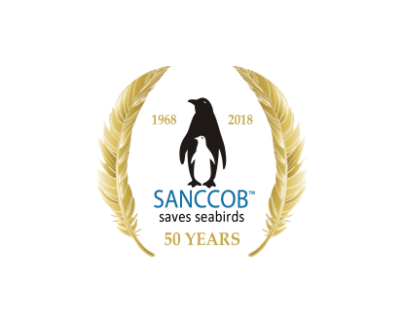
Saturday – November 9th, 2019 - 1:00PM
36841 Clubhouse Dr.,
Zephyrhills, Fl. 33542
Entrance fee: $65.00 Includes: Golf & Meal (served from 4-6pm)
Prize Pack: $10.00 Includes: 2 Raffle tickets & Course Contests
Heckler Zone: $25.00 Includes: Lunch & Tap Beer/Soft Drinks (1:00pm – 5:30pm)
Corn Hole: $10.00 Includes: Team entry to tournament (Teams of 2)
For Registration, Sponsorship & Information: www.tampabayaazk.com
Spectators Welcome - Educational Animal Interactions
Kid’s Activities - Raffle & Auction Items

